Akash Badshah

6.115 Final Project Proposal

Electronic Bulls-eye Board & Nerf Dart Launcher

**Background & Introduction**

For the 6.115 Final Project I propose an electronic bulls-eye board and servo controlled nerf dart launcher. Games like darts are a lot of fun but require a special kind of projectile that implants itself in the board in order to be scored by eye. These systems are limited because they require special equipment and also have static board patterns (a concentric circle bulls-eye for example). To get around this limitation I want to make a target that records the impact coordinates of any arbitrary projectile and allows the user to put different pieces of paper with different patterns on them behind the target, allowing for arbitrary board patterns to be scored as the user wishes.

In addition, I would like the game to be end-to-end controllable electronically, so I will create a proof-of-concept electronic dart firing system which can be controlled either by the user’s input, or by an algorithmic aiming system. I would do this by taking an existing 2-axis controllable electronic nerf dart launcher and hacking it to be controllable by the PSoC.

This project presents several technical challenges in both the targeting and firing system. For the target, the position detection system has to be fast enough to see the dart as it passes through the target, and would need to compute a position with enough precision to allow for accurate scoring. From the launching system, the electronic launcher would need to be interfaced through a laptop USB and then to the PSoC. Furthermore, developing an appropriate automated launching system would be both an interesting application of feedback loops and in algorithm development.

**Hardware Description**

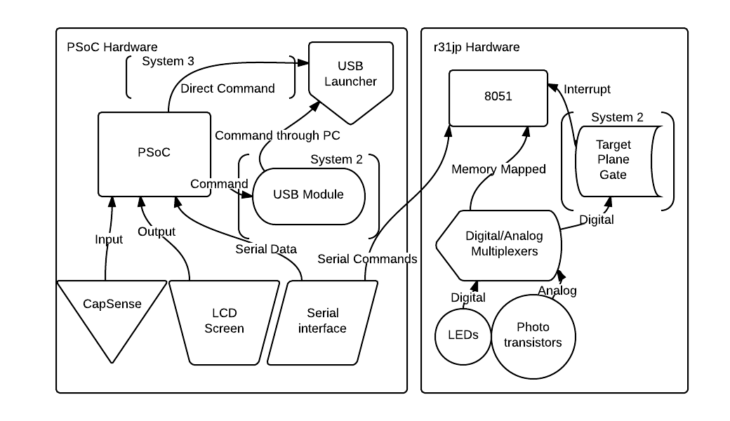

The hardware required for this system consists of two components: the target and the launcher, which are controlled by the r31jp and PSoC, respectively.

The electronic target would be a square frame consisting of 32 IR LEDs on two sides, and 32 IR Phototransistors on the other two sides. These LEDs and Phototransistors would be interfaced through digital and analog multiplexers to the r31jp or an ADC connected to the r31jp. It would scan through these pairs much like SpinDude and compute a position based on the dart occluding the light path. In addition, I would like to add a digital logic section that triggers the scanning process when the dart breaks the initial plane of the target. This r31jp system would be connected to the PSoC system via serial.

The launching system would largely involve controlling a USB nerf missile launcher, either through a computer’s USB protocol that waits for input from the PSoC and sends it back to the launcher, or by directly hacking into the hardware and driving the motors directly from the PSoC. If the former option were chosen, the PSoC would be configured with a USB module to communicate with the computer. The PSoC would also have a serial connection to the r31jp, and would take the position computed by the r31jp and compute a score based on which bullseye pattern the user has selected (via the PSoC CapSense interface and the LCD screen output).

**Software Description**

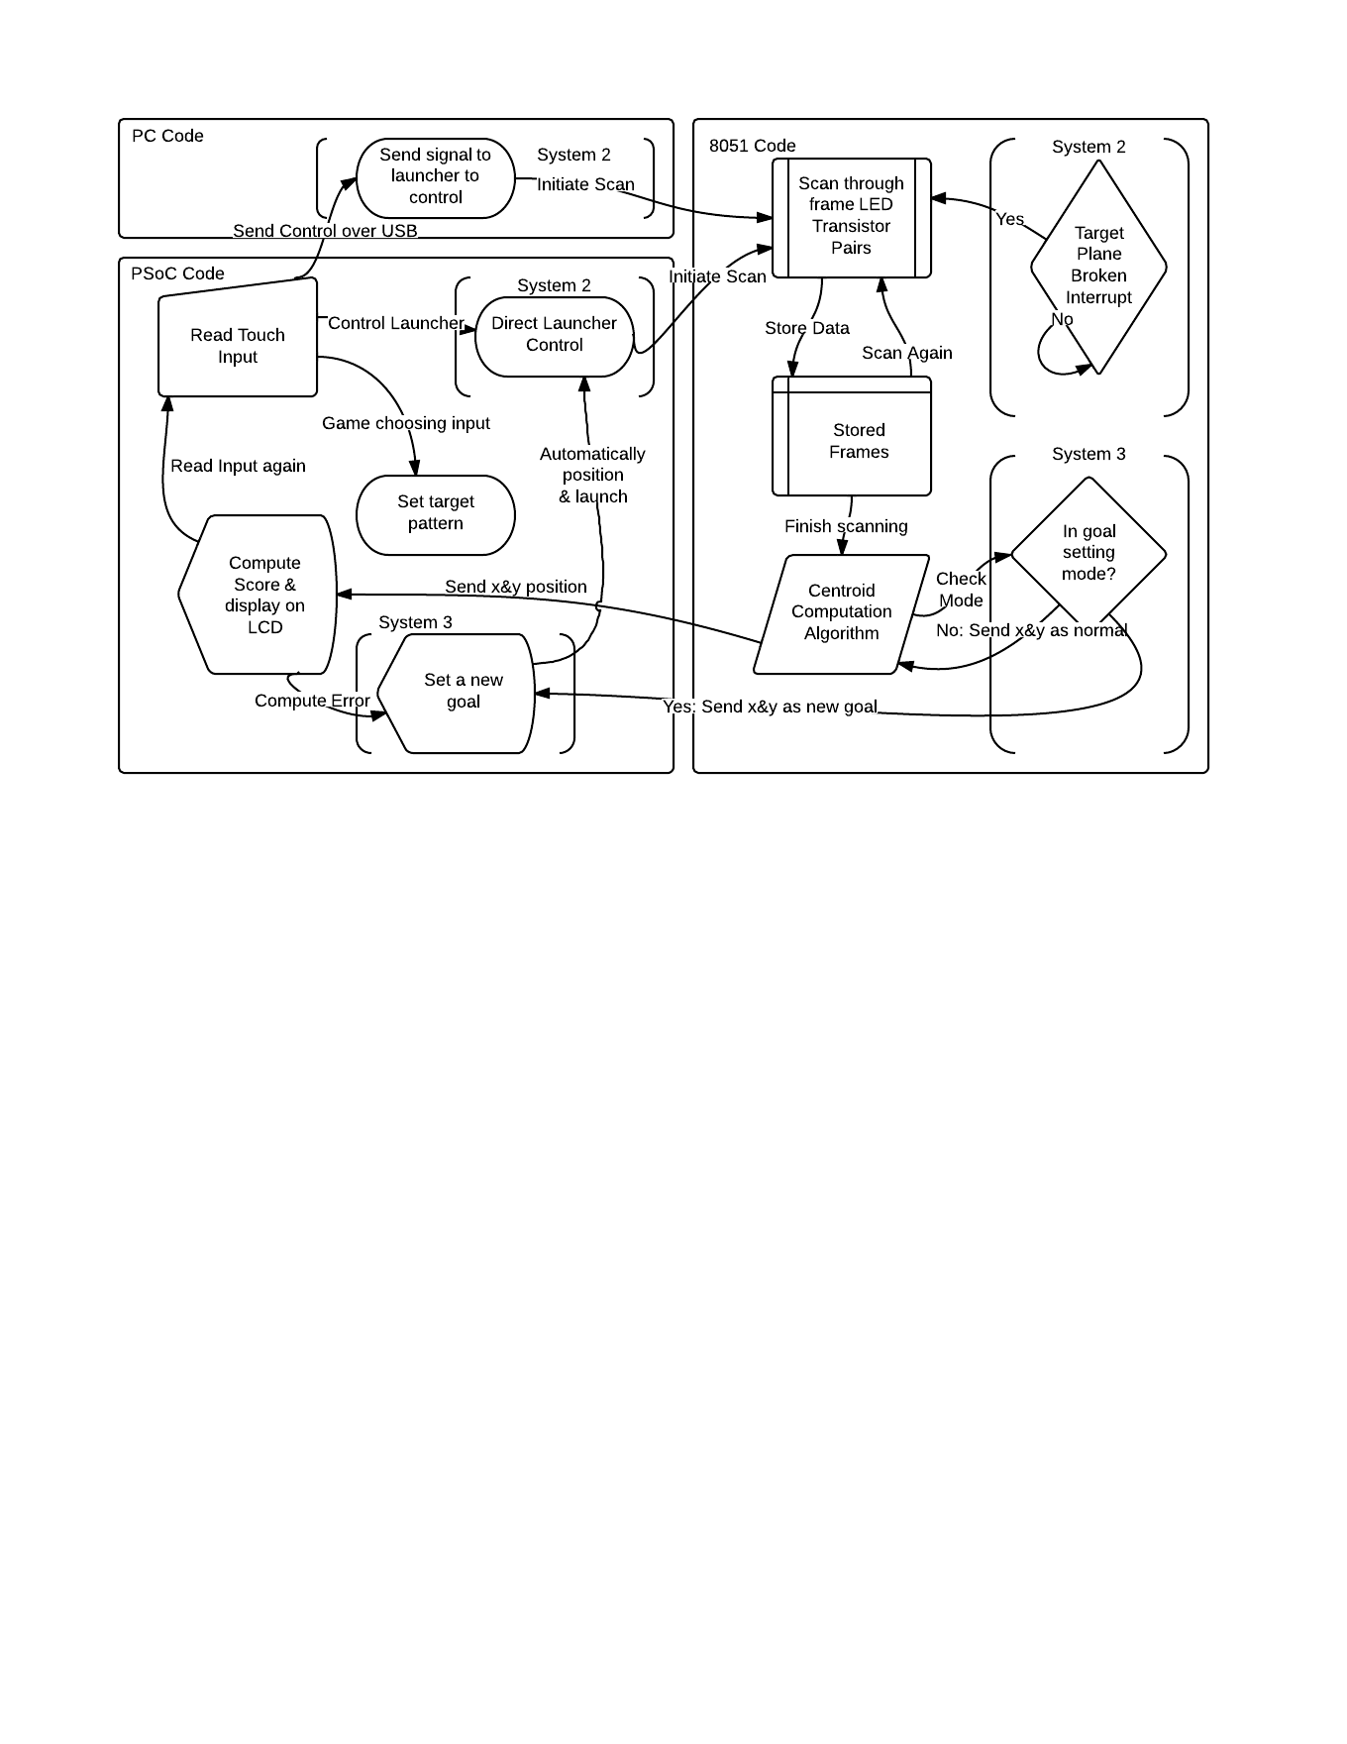

The software required to run on the targeting system is very similar to the software required to run the SpinDude, except computations will be done on the r31jp instead of through Matlab. Upon receiving a signal from the PSoC over serial, the r31jp will initiate a scan through each of the 64 LED/Phototransistor pairs, and will store an analog value for each one. Each of these analog values will be used to weight that position and, by using a traditional centroid computation, will result in an x & y position for the dart. That pair of data constitutes one frame and the r31jp will take as many frames as necessary to be sure the dart has completed its flight. Eventually it will filter out the blank frames, and average the non-blank ones to output a final x & y position across serial to the PSoC. If the r31jp has a logic system to detect when the projectile breaks the surface, it will instead initiate its scan on this interrupt and stop when the signal is off again.

The PSoC will run software that makes it the interface between user input (on the CapSense), projectile control (via the USB-launcher), and user output (on the LCD). It will wait for input on the CapSense buttons which will allow the user to select between target patterns (which they can visually apply to the target via a piece of paper) and to control the 2-axis USB-launcher. The PSoC will control this launcher either by sending commands to the computer over a USB protocol (which a python script will echo to the launcher) or will directly drive the servo motors in the launcher via PWM signal. The PSoC is not capable of controlling the launcher directly over USB because it cannot act as a host.

If the PSoC is running in automated mode, it will have an additional software module which uses the data from the previous shots to adjust the aim of the launcher automatically in order to hit some specified target the user wishes. One possible way of specifying this target would be to put the r31jp into a separate mode, and have the user point to a place on the target board. The r31jp would then run a scan, compute a desired position, and send it to the PSoC as the goal.

**Project Management & Scope**

The goals of this project are separated into three groups, with each group ending with some finished and usable product.

The first system will include the target board that computes the position of some projectile after receiving a signal from the PSoC over serial. This system would contain the r31jp system as described, without the logic to detect the dart breaking the target plane or the automated aiming & target setting. The PSoC system would have no method of controlling the launcher, instead having the software for control reside on the laptop that the launcher is plugged into. Instead the PSoC in this version would allow the user to pick from several bulls-eye patterns with the CapSense & LCD and then compute the scores & keep a running scoreboard for the game.

The second system will feature additional hardware and software components on both systems. For the r31jp target board, logic would be added to trigger an interrupt when the projectile breaks the plane of the target and thus reduce the number of waste frames collected. This would replace the signal sent over serial from the PSoC and require the use of some programmable gate array. The PSoC will be configured with a USB module to communicate with the computer and allow the PSoC to take input on the CapSense and relay it to the launcher. This would allow the user to control the launcher through the PSoC.

The final system will feature additional software and hardware on the PSoC system, and additional software on the r31jp. For the PSoC, the USB module approach will be abandoned in favor of directly driving the hardware in the usb-launcher from the PSoC’s outputs. In addition, software will be added to allow for automatic targeting according to some preset goal. The r31jp will include additional software for the selection of this goal, with some mode that takes the position of a user’s finger and makes that the goal.

**Special Component Needs**

For this project I will need the same hardware required for SpinDude (minus the motor) and the usb-launching system. The target requires IR LEDs, IR phototransistors, analog multiplexers, and digital multiplexers. If the logical plane gate is implemented it will also require a programmable gate system that can generate a digital pulse on impact of the projectile. The launching system will use an out of the box usb dart missile launcher, and potentially hack directly into the hardware for control.

**Timetable:**

Week of April 14: Project & part research, revision of project idea and final project spec

Week of April 21: Build LED/Phototransistor frame & test with static objects

Week of April 28: Basic PSoC software to select a game, finishing of system 1

Week of May 5: PSoC interface to usb-launcher & logic trigger on the target

Week of May 12: Attempt to hack usb-launcher for direct control & automated shooting system